A
Real-Time Research Project Report
On

IRIS RECOGNITION THROUGH MACHINE LEARNING TECHNIQUES
(Submitted in partial fulfillment of the requirements for the award of Degree)

BACHELOR OF TECHNOLOGY
In

COMPUTER SCIENCE AND ENGINEERING (DATA SCIENCE)

By
D.VARSHA (247R1A67E9)
O.ASHISH(247R1A67D3)
N.BALAJI(247R1A67G9)
T.CHARAN(247R1A67J1)

Under the Guidance of

Dr. K. Murali
Associate Professor & HOD-CSE(DS)


DEPARTMENT OF COMPUTER SCIENCE AND ENGINEERING (DATA SCIENCE)
CMR TECHNICAL CAMPUS
UGC AUTONOMOUS
(Accredited by NAAC, NBA, Permanently Affiliated to JNTUH, Approved by AICTE, New Delhi)
Recognized Under Section 2(f) & 12(B) of the UGCAct.1956, Kandlakoya (V), Medchal Road, Hyderabad-501401.
April, 2026.

DEPARTMENT OF COMPUTER SCIENCE AND ENGINEERING (DATA SCIENCE)



CERTIFICATE

This is to certify that the project entitled “IRIS RECOGNITION THROUGH MACHINE LEARNING TECHNIQUES” being submitted by D.VARSHA (247R1A67E9), O.ASHISH (247R1A67D3), N.BALAJI (247R1A67G9), T.CHARAN (247R1A67J1) in partial fulfillment of the requirements for the award of the degree of B.Tech in Computer Science and Engineering to the Jawaharlal Nehru Technological University Hyderabad, during the year 2025-2026.

The results embodied in this thesis have not been submitted to any other University or Institute for the award of any degree or diploma.

Dr. K. Murali Dr. K. Murali
Associate Professor HoD-CSE(DS)
INTERNAL GUIDE


CMR TECHNICAL CAMPUS
UGC AUTONOMOUS
(Accredited by NAAC, NBA, Permanently Affiliated to JNTUH, Approved by AICTE, New Delhi)
Recognized Under Section 2(f) & 12(B) of the UGCAct.1956, Kandlakoya (V), Medchal Road, Hyderabad-501401.

Department of CSE [Data Science]

Program Specific Outcomes (PSOs):
PSO-1: Apply the principles and conduct investigations in data science for sustainable development.
PSO-2: Explore data science research and applications to solve industry and societal challenges.
PSO-3: Promote communication, ethics, and lifelong learning with a focus on social responsibility.

Program Educational Objectives (PEOs):

PEO-1: Graduates will have the ability to apply data science techniques to develop innovative solutions for real-world problems.
PEO-2: Graduates will have the ability to pursue research and higher education in the data science and aligned fields.
PEO-3: Graduates will have the ability to become ethically driven leaders and innovative entrepreneurs in data science domain.


CMR TECHNICAL CAMPUS
UGC AUTONOMOUS
(Accredited by NAAC, NBA, Permanently Affiliated to JNTUH, Approved by AICTE, New Delhi)
Recognized Under Section 2(f) & 12(B) of the UGCAct.1956, Kandlakoya (V), Medchal Road, Hyderabad-501401.

Department of CSE [Data Science]

Institute Vision & Mission
Vision:
- To Impart quality education in serene atmosphere thus strive for excellence in Technology and Research.

Mission:
- To Create state of art facilities for effective Teaching- Learning Process.
- Pursue and Disseminate Knowledge based research to meet the needs of Industry & Society.
- Infuse Professional, Ethical and Societal values among Learning Community.

Department Vision & Mission
Vision:
- To provide a quality education and research environment in Data Science that fosters innovation and technological advancement to meet global challenges.

Mission:
- To provide an industry-aligned data science curriculum to develop strong analytical and problem-solving skills.
- To foster a research-driven environment that promotes innovation and technological advancements.
- To promote lifelong learning, teamwork and ethics for global challenges.


CMR TECHNICAL CAMPUS
UGC AUTONOMOUS
(Accredited by NAAC, NBA, Permanently Affiliated to JNTUH, Approved by AICTE, New Delhi)
Recognized Under Section 2(f) & 12(B) of the UGCAct.1956, Kandlakoya (V), Medchal Road, Hyderabad-501401.

Department of CSE [Data Science]

Program Outcomes (POs):

PO1: Engineering Knowledge: Apply knowledge of mathematics, natural science, computing, engineering fundamentals and an engineering specialization to develop to the solution of complex engineering problems.
PO2: Problem Analysis: Identify, formulate, review research literature and analyze complex engineering problems reaching substantiated conclusions with consideration for sustainable development.
PO3: Design/Development of Solutions: Design creative solutions for complex engineering problems and design/develop systems/components/processes to meet identified needs.
PO4: Conduct Investigations of Complex Problems: Conduct investigations of complex engineering problems using research-based knowledge.
PO5: Engineering Tool Usage: Create, select and apply appropriate techniques, resources and modern engineering & IT tools.
PO6: The Engineer and The World: Analyze and evaluate societal
and environmental aspects while solving complex engineering problems.
PO7: Ethics: Apply ethical principles and commit to professional ethics, human values, diversity and inclusion.
PO8: Individual and Collaborative Team work: Function effectively as an individual, and as a member or leader in diverse teams.
PO9: Communication: Communicate effectively within the engineering community and society.
PO10: Project Management and Finance: Apply knowledge of engineering management principles and economic decision-making.
PO11: Life-Long Learning: Recognize the need for independent and life-long learning.

ACKNOWLEDGEMENT

We take this opportunity to express our gratitude to the people who have been instrumental in the successful completion of this project, we take this opportunity to express our profound gratitude and deep regard to our guide Dr.K.Murali, Associate Professor & HOD-CSE(DS), monitoring and constant encouragement throughout the project work. The blessing, help and guidance given by him shall carry us a long way in the journey of life on which we are about to embark.
We also take this opportunity to express a deep sense of gratitude to the Project Review Committee (PRC) coordinators Laxman B, Sanjib Kumar Nayak for their cordial support, valuable information and guidance, which helped us in completing this task through various stages.
We are also thankful to Dr. K. Murali, Head, Department of Computer Science and Engineering (Data Science) for providing encouragement and support for completing this project successfully.
We are deeply grateful to Dr. A. Raji Reddy, Director, for his cooperation throughout the course of this project. Additionally, we extend our profound gratitude to Sri. Ch. Gopal Reddy, Chairman, Smt. C. Vasantha Latha, Secretary and Sri. C. Abhinav Reddy, Vice-Chairman, for fostering an excellent infrastructure and a conducive learning environment that greatly contributed to our progress.
The guidance and support received from all the members of CMR Technical Campus who contributed to the completion of the project. We are grateful for their constant support and help.
Finally, we would like to take this opportunity to thank our family for their constant encouragement, without which this assignment would not be completed. We sincerely acknowledge and thank all those who gave support directly and indirectly in the completion of this project.

D.VARSHA (247R1A67E9)
O.ASHISH (247R1A67D3)
N.BALAJI(247R1A67G9)
T.CHARAN(247R1A67J1)

ABSTRACT

This project is titled as “Iris Recognition Through Machine Learning Techniques”.
Iris recognition is one of the most promising fields in biometrics. Notwithstanding this, there are not so many research works addressing it by Machine Learning techniques. In this survey, we especially focus on recognition, and leave the detection and feature extraction problems in the background. However, the kind of features used to code the iris pattern may significantly influence the complexity of the methods and their performance. In other words, complexity affects learning, and iris patterns require relatively complex feature vectors, even if their size can be optimized. A cross-comparison of these two parameters, feature complexity vs. learning effectiveness, in the context of different learning algorithms, would require an unbiased common benchmark. Moreover, at present it is still very difficult to reproduce techniques and experiments due to the lack of either sufficient implementation details or reliable shared code.

TABLE OF CONTENTS

ABSTRACT |  |  |  | i
LIST OF FIGURES |  |  |  | ii
LIST OF TABLES |  |  |  | v
1. | INTRODUCTION |  |  | 1
 | 1.1 | PROJECT PURPOSE |  | 1
 | 1.2 | PROJECT FEATURES |  | 2
2. | LITERATURE SURVEY |  |  | 3
 | 2.1 | REVIEW OF RELATED WORK |  | 8
 | 2.2 | DEFINITION OF PROBLEM STATEMENT |  | 10
 | 2.3 | EXISTING SYSTEM |  | 10
 | 2.4 | PROPOSED SYSTEM |  | 12
 | 2.5 | OBJECTIVES |  | 13
 | 2.6 | HARDWARE & SOFTWARE REQUIREMENTS |  | 14
 |  | 2.6.1 | HARDWARE REQUIREMENTS | 14
 |  | 2.6.2 | SOFTWARE REQUIREMENTS | 14
3. | SYSTEM ARCHITECTURE & DESIGN |  |  | 14
 | 3.1 | PROJECT ARCHITECTURE |  | 14
 | 3.2 | DESCRIPTION |  | 15
 | 3.3 | DATA FLOW DIAGRAM |  | 16
4. | IMPLEMENTATION |  |  | 19
 | 4.1 | ALGORITHMS USED |  | 19
 | 4.2 | SAMPLE CODE |  | 25
5. | RESULTS & DISCUSSION |  |  | 37
6. | VALIDATION |  |  | 47
 | 6.1 | INTRODUCTION |  | 48
 | 6.2 | TEST CASES |  | 49
 |  | 6.2.1 | UPLOADING DATASET | 49
 |  | 6.2.2 | CLASSIFICATION | 49
7. | CONCLUSION & FUTURE ASPECTS |  |  | 49
 | 7.1 | PROJECT CONCLUSION |  | 49
 | 7.2 | FUTURE ASPECTS |  | 50
8. | BIBLIOGRAPHY |  |  | 51
 | 8.1 | REFERENCES |  | 51
 | 8.2 | GITHUB LINK |  | 52

LIST OF FIGURES

FIGURE NO | FIGURE NAME | PAGE NO
Figure 3.1 | Project Architecture of Iris Recognition Through Machine Learning Techniques | 14
Figure 3.2 | Dataflow Diagram of Iris Recognition through Machine Learning Techniques | 17
Figure 4.1 | Dataset directory structure with folders ‘Iris Recognition Through Machine Learning Techniques’ having all the training examples | 23
Figure 4.2 | Screenshot of the "Iris" Folder Showing Sample Image Files | 23
Figure 5.1 | GUI /Main Interface of Iris Recognition Through Machine Learning Techniques | 37
Figure 5.2 | Loaded the dataset of Iris Recognition Through Machine Learning techniques | 38
Figure 5.3 | View of CNN layers in Iris Recognition Through Machine Learning | 39
Figure 5.4 | Statistical Representation of Iris Recognition Through Machine Learning Techniques | 40
Figure 5.5 | Display of no. of items and labels present of Iris Recognition Through Machine Learning Techniques | 41
Figure 5.6 | Iris recognition of a person | 42

LIST OF TABLES

TABLE NO | TABLE NAME | PAGE NO
Table 6.2.1 | Uploading Dataset | 49
Table 6.2.2 | Classification | 49

INTRODUCTION

INTRODUCTION

The project, titled "Iris Recognition Through Machine Learning Techniques" is a highly reliable and accurate biometric authentication technique that uses the unique patterns present in the human iris for identification. These patterns are stable over a lifetime and difficult to replicate, making iris recognition a secure solution for applications such as access control, banking systems, and national identification programs. Compared to other biometric methods like fingerprint or facial recognition, iris recognition offers greater precision and resistance to forgery, which has led to increasing interest in its development and deployment.
Despite its advantages, the use of Machine Learning techniques in iris recognition, particularly in the recognition stage, has not been explored extensively. A major challenge lies in handling the complexity of iris feature patterns, as extracting and processing detailed feature vectors can affect both system performance and computational efficiency. This project focuses on improving iris recognition by analysing the relationship between feature complexity and learning effectiveness, while also addressing the need for better evaluation methods and reproducible research in this field.

PROJECT PURPOSE

The main purpose of this project is to develop an efficient and accurate iris recognition system using Machine Learning techniques. Iris recognition is a powerful biometric method due to the uniqueness and stability of iris patterns, but its full potential can be better utilized by applying advanced learning algorithms. This project aims to improve the recognition stage by implementing models that can learn complex patterns and enhance identification accuracy.
Another key objective of this project is to study the impact of feature complexity on the performance of Machine Learning algorithms. Iris images contain highly detailed textures, which require effective feature extraction methods to represent them accurately. However, complex feature vectors can increase computational cost and affect learning efficiency. Therefore, this project focuses on finding a balance between feature complexity and model performance to achieve optimal results.
The project also aims to promote fair evaluation and reproducibility in iris recognition research. Many existing studies lack standardized benchmarks and sufficient implementation details, making it difficult to compare results. By creating a structured approach and analysing different algorithms under consistent conditions, this work seeks to provide a more reliable framework for future research and development in biometric systems.

PROJECT FEATURES
This project incorporates several key features to improve the accuracy and efficiency of iris recognition systems using Machine Learning techniques by:
Machine Learning Bases Iris Recognition: This project utilizes advanced Machine Learning algorithms, such as Convolutional Neural Networks (CNNs) or classification models, to accurately recognize and classify iris patterns. The system is trained on a dataset of iris images, allowing it to learn unique features associated with each individual. By automating the recognition process, the model improves identification accuracy, reduces human intervention, and performs well even with slight variations in lighting, angle, or image quality.
Optimized Feature Extraction and Representation: A crucial feature of the project is the extraction of meaningful and discriminative features from iris images. The iris contains intricate textures, and capturing these details is essential for accurate recognition. The project applies preprocessing techniques such as image normalization, noise removal, and segmentation to isolate the iris region. It then converts the extracted patterns into structured feature vectors that balance complexity and efficiency, ensuring that the Machine Learning model can process them effectively without excessive computational cost.
By integrating these features, this ML-based system provides a powerful and scalable solution for accurate iris-based authentication.

LITERATURE REVIEW

2. LITERATURE REVIEW

The literature review chapter has been mainly provided with a detailed description of the various problems and different types of recognition aspects that has been mainly associated with the entire area of the research study. The fundamental research has been conducted with the help of the different types of research notes of different authors and researchers. The entire process is also evaluated by the brief description of the research from the different online articles, journals and various websites.
The fundamental research has been conducted with respect to the in-depth analysis process of the entire Validation based recognition system. Including all of these, this particular chapter has also demonstrated the particular models and theories of the proposed topic for evaluating the entire description process. In this part, there are also described the literature gaps that are generally missing in the existing research notes of various authors.
According to the author Alrahawe (2018), a biometric system is one of the safest ways to work with the digital world. Since biometrics such as fingerprints, face, and iris recognition are different for different persons, these are safer compared to any other processes to secure confidential data (Alrahawe, 2018). However, in the olden days, there was a lack of technology for which there was less security provided for any confidential information. With the advancement in technology in recent times, biometric security has been an integral part of any system. Moreover, the author states that these kinds of processes for security in digitalization have become error-free, for which this system is getting implemented in the latest systems (Singh & Kant, 2021). Due to minor errors in the system, this is pretty reliable for security purposes. The biometric system has used various types of recognition processes, among which it also uses the finger-knuckle recognition system.

According to the author Elhoseny (2018), there was a unimodal system for identification and verification processes. However, through the unimodal system, the accuracy was not fully maintained since it failed to meet the proper decision-making criteria. It was found that there was a significant amount of reduction in accuracy while using the unimodal system for verification (Elhoseny, 2018). Thus the multimodal system was introduced. As the multimodal system uses fusion technology, the overall accuracy from the verification was achieved. While comparing the different sorts of modalities, fingerprint and iris always have the highest distinctiveness and permanence. Moreover, they are cost-efficient too, and the speed is relatively higher when compared to any other modalities. While the unimodal system was not totally involved in the decision making concept, the multimodal system covers four different tasks such as acquisition, extracting the feature from the modalities, matching with the actual one and then providing the decisions (La, 2021). The unimodal systems are also used in many cases where less security can be helpful. But for high-security purposes and the sectors that deal with massive amounts of confidential data require multimodal systems.

According to the author Adamu (2019), the biometric system has been dealt with the particular types of the technical and technological field and department for controlling the entire body dimensioning process. The process has also been stated to have different types of metrics that are directly related to the proper characteristics of the human being (Adamu, 2019). Biometric verification has mainly proposed various types of processors as the accurate method for accessing the complete human body control and human process control. The system has generally dealt with the proper identification and measurement of the individual's process for correctly clustering the various techniques under proper investigation (Regouid et al., 2019). The biometric process is the most unique and contains valuable features and factors to describe all the entities. This particular technology is an excellent addition to the best innovation, and it is very much helpful and necessary for the higher quality business cases that are mainly faced by different types of massive data violation processes. Biometric recognition is a valid and reliable method to verify the real personality of the living person that is totally dependent on physiological qualities and social qualities (Naika, 2018). All these kinds of assumptions are basically constant and irreversible processes without noticeable stress (academia.edu, 2019).

According to the author Garg & Gupta (2017), iris recognition has been mainly considered as the popular types of biometric methods for the purpose of the human identification procedures and verification stages. This particular method is mainly used for the purpose of the unique characteristics and unique features and aspects that have been mainly used to show the dissimilarity between all persons with respect to the security purpose. The entire study has proposed the multi algorithmic characteristics for the proper types of extraction techniques in the case of the personal iris recognition process. The ultimate localization and the segmentation technologies are used with respect to the circular transformation process (Garg & Gupta, 2017). The process can be used for isolating the iris from the entire human body for detecting the particular noise. With the various types of factors, the investigation process should be quickly done with respect to the specific angles, ergonomic aspects and features, and various types of mental viewpoints of the customer. The entire has been enhanced for the case of the best impression of the particular impression of the client based on the proper convenience stages of the specific biometrics. These specific factors have been compromised with the proper adequacy level and the best effectiveness on the concentration process (Nelufule & de Kock, 2020). The ergonomic features have been mainly considered various types of physical attributes and psychological attributes of the clients, such as availability, affordability (academia.edu, 2017).
With respect to the research note of the author Gogate & Azad (2021), the biometric oriented individual identification process has been mainly observed like the practical and particular necessary techniques. All the techniques are mainly used for the automatic working process and working performance with the high quality of the confidence levels for proper identification of the person (Gogate & Azad, 2021). The multimodal oriented biometric system has been mainly consolidated with proper access with respect to the respective biometric modality sources by the actual evidence. This particular system has used different types of technologies for properly overcoming the various types of issues and challenges based on the combination of the various types of informative data under the same identity process (Oyeniran & Oyeniyi, 2019). In this case, all the ethical issues have been mainly done with respect to the proper acceptance of the fingerprint method for validation of the system to enhance the complete security and privacy based networking system to increase the validity rates. The facial acknowledgement process and administration oriented various types of issues can be easily solved by the uniqueness of the entire process and specific characteristics of the fingerprint-based iris recognition process. The entire type of recognition system can be done quickly with the help of the "convolution neural networks (CNN)" (Wang et al. 2018). The best types of biometric framework have generally included various types of methods and proper consolidation of the best innovative working procedures with respect to the internet of things (IoT) process in the entire system. With the help of advanced and modern technologies, security risks and privacy errors can be easily reduced.

According to the author Arora and Bhatia (2018), the brilliant development of the entire system has been done with respect to the different types of intelligent devices that are mainly connected with different services. For this purpose, every smart device has been mainly designed for providing accurate user-centric based working services (Arora and Bhatia, 2018). This service has been improved for gathering the personal and confidential information of the customer under this condition and situation. This recognition system has been mainly used for preventing the personally gathered information from unintentional leakage. This process is very much crucial for preventing all types of risk factors. For this purpose, the appropriate user id and password has been mainly used for the user authentication cases. The entire method is the convenient type of method for the iris recognition system. This particular method has particular types of vulnerability, which is the main effect of the leakage of personal information. To reduce this risk, different types of methods and procedures have been used that are mainly related to the face recognition process that has been mainly used for the purpose of the validation system. With the help of this research paper of this author, the proper investigation is the primary trend for the case of user authentication with respect to the biometric process. This particular system also included the "representative model for the face recognition techniques". All these procedures and techniques are mainly done through the "convolutional neural network (CNN)" model.
With the help of the research note of the author, Attia et al. (2020) state that in the present time, the innovative biometric process has made the most significant difference between all people with the help of the various types of methods. This method is mainly experimented with through the human body parts and mainly done by the proper utilization of the human body qualities to identify or verify the different types of essential and efficient purposes and values. The sound effect of the proper advancement of the biometric process has been mainly done to meet the open obstruction process. Including all of these, the biometric process must be associated with the proper defamation due to the long term based for permanent use of the fingerprints in recognizing all the crooks (Attia et al. 2020). The final evaluation of the biometric framework should be client-driven and should be very easy for the proper evaluation of the biometric gadget. The particular specialized approach has the adequacy and the functionality that has been widely centralized in light of the moving patterns that have enhanced the client's wellbeing process. The fundamental and the primary value of this is to assess all the required benefits of those intelligent gadgets without elaborating all the strategies such as education for the respective client of the system.
According to the author Cardia Neto (2020), the multimodal biometric system has been mainly used for the purpose of both behavioral features and psychological features to properly verify the exact user. For the purpose of showing the real-time values and proper applications, the systems have been mainly used within the "unimodal biometric system" for both the security user and then authenticate the user (Cardia Neto, 2020). This particular identification process is mainly based on the different types of representation of the developed biometric process. This particular process has developed the "multimodal biometric system" that has been mainly integrated with the face identification and speech identification recognition system for the system user verification. In the present situation, the data security process and the authentication system within the "unimodal biometric process" is very much necessary and essential for the security purpose. All the general information such as virtual devices, passwords, smart cards, various types of ID cards and good numbers do not initially improve all the possible strategies under the appropriate secure environmental situation. This particular type of "multimodal biometric system" for both the facial recognition process and the speech recognition process has been done with respect to the ICA algorithms and the GTCC algorithmic features and factors. All the information about the particular method has been mainly compiled by the fusion methods such as the feature level, skew level and the proper sensor level that each system has its own probability of the accurate matching score. All these methods can be easily implemented with the appropriate classification technique, such as the “convolutional neural network (CNN)” within the training section and the testing section (academia.edu, 2019).

REVIEW OF RELATED WORK

The recognition of iris patterns has been widely studied in the fields of biometrics, computer vision, and machine learning. Several approaches have been proposed to address this problem, ranging from traditional image processing and pattern-matching techniques to advanced machine learning and deep learning models. This review discusses previous research and existing methodologies in iris recognition, highlighting their strengths, limitations, and the impact of feature complexity on recognition performance.

    - Traditional Iris Recognition Approaches

Earlier research in iris recognition mainly focused on classical image processing techniques such as edge detection, segmentation, and pattern matching. Methods like Gabor filters and wavelet transforms were widely used to extract iris features. While these approaches achieved good accuracy, they lacked adaptability and struggled with variations

    - Limited Adoption of Machine Learning Techniques

Although iris recognition is a mature biometric field, only a limited number of studies have applied Machine Learning methods. Most existing works rely on rule-based or handcrafted feature extraction techniques instead of learning-based models. This limits the system’s ability to automatically improve performance from data and handle complex variations in iris patterns.
    - Trade-Off Between Future Complexity and Efficiency

A major focus in related work is on feature extraction, as it directly affects recognition performance. Researchers have proposed different feature encoding methods to represent iris textures effectively. However, complex feature vectors, while more descriptive, often increase computational cost and make the learning process more difficult.
    - Future Research Directions Identified

The reviewed works suggest the need for integrating optimized feature extraction with advanced machine learning models, creating standard datasets and benchmarks, and improving reproducibility. There is also a growing interest in combining deep learning with lightweight models for efficient and scalable iris recognition systems.

However, these models require massive computational resources and extensive pre- training on large datasets.

    - Comparison with the Proposed Approach

Improved Balance Between Feature Complexity and Performance
Unlike many existing methods that either rely on highly complex feature vectors or overly simplified representations, the proposed approach achieves a better balance between feature complexity and learning efficiency. By using optimized feature extraction along with a machine learning model, the system reduces computational cost while maintaining high recognition accuracy, making it more practical and scalable compared to traditional and some deep learning-based approaches.

DEFINITION OF PROBLEM STATEMENT
Iris recognition using machine learning techniques is a biometric identification problem that aims to automatically identify or verify an individual based on the unique patterns of their iris. It involves capturing iris images, preprocessing them, extracting distinctive features, and using machine learning algorithms to classify and match these features with stored records in a database.
The goal is to develop a system that is accurate, reliable, and efficient, even under varying conditions such as changes in lighting, image quality, and eye position, ensuring secure and robust personal identification.

EXISTING SYSTEM

The existing iris recognition systems are primarily based on traditional image processing and pattern recognition techniques. These systems typically follow a fixed pipeline that includes iris image acquisition, segmentation, normalization, feature extraction, and matching. Classical methods such as edge detection, Hough Transform, and Gabor filters are commonly used to locate the iris region and extract features. While these approaches have been widely used, they often rely on handcrafted features and predefined rules, which limit their adaptability to variations in real-world conditions.
In many existing systems, feature extraction plays a crucial role and is usually performed using techniques like wavelet transforms or texture-based analysis. The extracted features are then compared using distance measures such as Hamming distance for identification or verification. Although these methods can achieve reasonable accuracy in controlled environments, their performance tends to degrade when dealing with noise, occlusions (like eyelids or eyelashes), and changes in illumination.
Another limitation of traditional iris recognition systems is their dependency on high-quality images and controlled acquisition setups. They often require specialized hardware and consistent environmental conditions, making them less practical for large-scale or real-time applications. Additionally, these systems may struggle with scalability and processing speed when handling large databases, highlighting the need for more advanced and intelligent approaches such as machine learning-based methods.

2.3.1 Limitations of Existing System

Despite improvements in iris classification, the existing system suffers from the following challenges:
- Dependence on Hand-Crafted Features: Traditional systems rely on manually designed features (like Gabor filters and wavelets).
These features may not capture all the complex patterns of the iris, reducing accuracy when variations occur. They also require expert knowledge and are not adaptable to new data patterns.
- Sensitivity to Occlusions: Iris images are often partially blocked by eyelids, eyelashes,glasses.
Traditional techniques struggle to handle such occlusions, leading to incorrect feature extraction and mismatches.
- Scalability Issues: When deployed in large systems, performance degrades Hence,
The system struggles to maintain speed and accuracy simultaneously.

PROPOSED SYSTEM
The proposed system enhances iris recognition by using advanced Machine Learning techniques, particularly a Convolutional Neural Network (CNN), to automatically learn and extract complex iris patterns. Unlike traditional methods that depend on handcrafted features, this approach enables the model to identify unique characteristics directly from iris images. The system includes key stages such as image acquisition, preprocessing, and normalization, where noise reduction and image enhancement techniques are applied to improve quality and consistency. These processed images are then used to train the CNN model, allowing it to accurately recognize and differentiate between individuals even under varying conditions.
Additionally, the system focuses on balancing feature complexity with learning efficiency by leveraging deep learning’s ability to select the most relevant features automatically. This reduces manual effort while improving recognition accuracy and robustness. The trained model can handle variations such as lighting changes, occlusions, and image noise, making it suitable for real-world applications. Overall, the proposed system offers a scalable, efficient, and highly accurate solution for iris recognition, addressing the limitations of traditional approaches through automation and improved adaptability.

2.4.1 Advantages of the Proposed System:
The proposed system significantly improves upon the existing approaches by addressing key limitations:

- Higher Accuracy: The use of Convolutional Neural Networks (CNN) enables the system to learn complex iris patterns automatically. This improves recognition accuracy compared to traditional methods that rely on manual feature extraction.
- Robust to Variations: The proposed system can handle changes in lighting conditions, noise, and partial occlusions. This makes it more reliable in real-world scenarios where perfect image conditions are not always available.
- Automatic feature Extraction: The system does not depend on handcrafted features. Instead, the ML model extracts important features directly from images, reducing human effort and minimizing errors caused by manual design.
- Reduced Computational Complexity: By learning only the most relevant features, the system avoids unnecessary data processing. This optimizes performance and reduces computational cost compared to traditional high-dimensional feature methods.
- Improved Adaptability: Machine Learning models can be retrained or fine-tuned with new data, allowing the system to improve over time and adapt to new environments or conditions.

OBJECTIVES

- To implement a Convolutional Neural Network (CNN) for automated feature extraction&Classification.
This objective focuses on using a CNN model to automatically learn important features from iris images. It eliminates the need for manual feature extraction and improves the system’s ability to classify and recognize individuals.
- To monitor and minimize the loss during the training process to improve model performance
During model training, loss represents the error between predicted and actual results. By continuously monitoring and reducing this loss, the system becomes more accurate and reliable over time.
- To maximize the accuracy of recognition so that employees can be correctly identified from iris images
The goal is to achieve the highest possible recognition accuracy, ensuring that each employee is correctly identified without false matches or rejections.
- To validate the system’s performance using visual recognition results and ensure reliability.
This objective ensures that the system is tested and evaluated using real-time or sample results. Validation helps confirm that the system performs well in practical environments and can be trusted for actual use.

HARDWARE & SOFTWARE REQUIREMENTS

    - HARDWARE REQUIREMENTS:
Hardware interfaces specify the logical characteristics of each interface between the software product and the hardware components of the system. The following are some hardware requirements,

- Iris Camera | : | 2 MP, NIR support
- Processor (CPU) | : | Intel i5 / Ryzen 5 or higher
- RAM  - Storage | :  : | Minimum 8GB.  256 GB SSD

    - SOFTWARE REQUIREMENTS:
Software Requirements specifies the logical characteristics of each interface and software components of the system. The following are some software requirements,

- Operating system : Windows 10/11 LINUX
- Language : Python 3.8 or Higher
- Image Processing Library : Open CV 4.x
- ML Frame Work : TensorFlow / PyTorch (latest stable version)

SYSTEM ARCHITECTURE & DESIGN

SYSTEM ARCHITECTURE & DESIGN

Project architecture refers to the structural framework and design of a project, encompassing its components, interactions, and overall organization. It provides a clear blueprint for development, ensuring efficiency, scalability, and alignment with project goals. Effective architecture guides the project's lifecycle, from planning to execution, enhancing collaboration and reducing complexity.

PROJECT ARCHITECTURE

This System captures iris images, processes them using a CNN model, and identifies individuals based on extracted features.
Its design follows a modular pipeline to ensure accurate, efficient, scalable recognititon
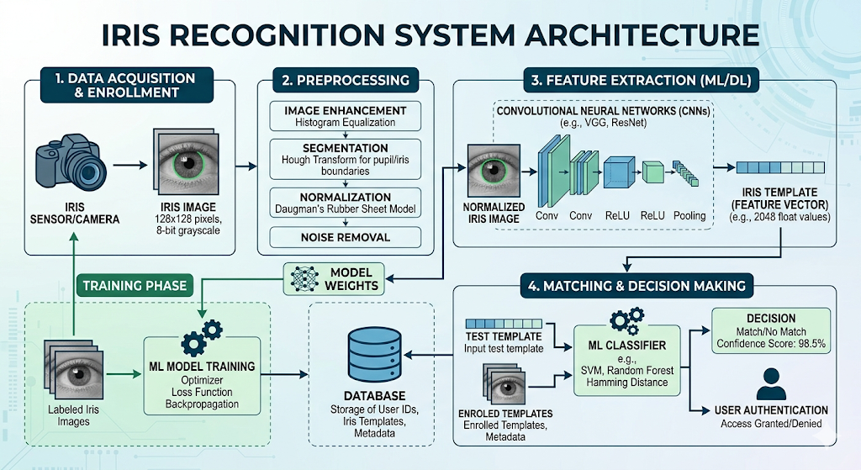

Figure 3.1: Project Architecture of Iris Recognition Through Machine Learning Techniques

DESCRIPTION

Input Data: The iris image is captured using a camera or sensor.

Reading Data: The captured image is loaded into the system for further processing.

Preprocessing: The image is enhanced, and the iris region is isolated, normalized, and cleaned.

Feature Extraction: A CNN model extracts unique patterns from the iris image.

Template Creation: The extracted features are converted into a digital template.

Matching: The generated template is compared with stored templates in the database.

Decision: The system determines whether it is a match or not and provides authentication.

DATA FLOW DIAGRAM
A Data Flow Diagram (DFD) is a graphical representation that illustrates how data flows within a system, showcasing its processes, data stores, and external entities. It is a vital tool in system analysis and design, helping stakeholders visualize the movement of information, identify inefficiencies, and optimize workflows.
A Data Flow Diagram comprises Four primary elements:
    - External Entities: The user is the person whose iris is being scanned for identification or authentication.
    - Processes: Indicate transformations or operations performed on data.
    - Data Flows: Depict the movement of data between components.
    - Data Stores: Represent where data is stored within the system.

These components are represented using standardized symbols, such as circles for processes, arrows for data flows, rectangles for external entities, and open-ended rectangles for data stores.

Benefits:
A Data Flow Diagram (DFD) helps in clearly visualizing how data moves within a system, making it easier to understand and design. It improves communication among developers and stakeholders, identifies errors early, and supports better system planning and documentation.
Applications:

DFDs are widely used in software development, system analysis, and database design to model data movement. They are also useful in business process modeling, web/app development, and security systems like iris recognition for designing efficient workflows.
Levels of DFD:
DFDs are structured hierarchically:

- Level 0 (Context Diagram): This is the highest-level diagram that shows the entire iris recognition system as a single process, where the user provides an iris image and receives the authentication result (match/no match), along with interaction with the database.

- Level 1: This level breaks the system into major processes such as iris image capture, preprocessing, feature extraction, template generation, and matching, showing how data flows between these components and the database.

- Level 2+: This Level gives a very detailed internal workflow, such as step-by-step CNN layers, Algorithm calculations, and matching techniques, mainly used for technical implementation and deep system analysis.

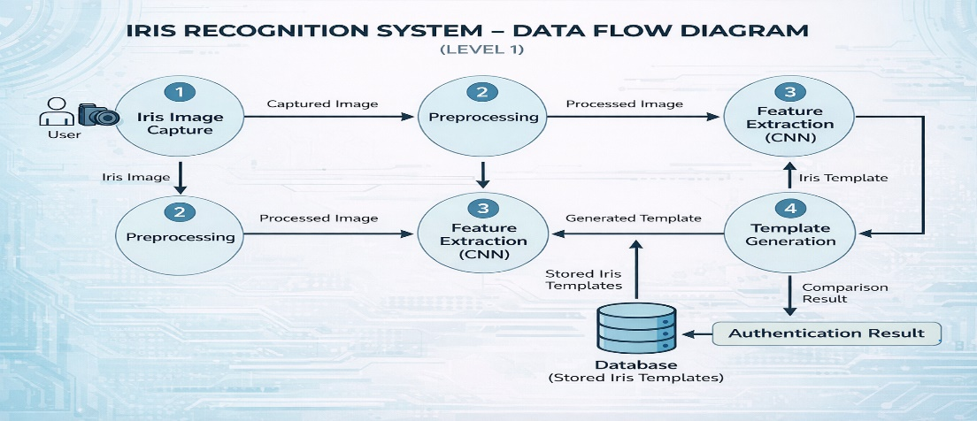
Figure 3.2: Dataflow Diagram of Iris Recognition through Machine Learning Techniques

IMPLEMENTATION

IMPLEMENTATION
The implementation phase of a project involves executing the planned strategies and tasks. It requires meticulous coordination, resource allocation, and monitoring to ensure that objectives are met efficiently. Effective implementation is crucial for achieving project goals and delivering expected outcomes within the set timeline and budget constraints.

4.1 ALGORITHMS USED

4.1.1 K- Nearest Neighbors(KNN)

K-Nearest Neighbors (KNN) is a simple and effective supervised machine learning algorithm used for classification in iris recognition systems. It works by comparing a new iris feature vector with stored feature vectors in the dataset and identifying the k closest matches based on a distance metric such as Euclidean distance. The class (person identity) is then assigned based on the majority vote among these nearest neighbors. In iris recognition, KNN is useful because it relies on similarity between complex iris patterns rather than building an explicit model. It is easy to implement and performs well for small to medium-sized datasets. However, it becomes computationally expensive for large datasets since it requires comparing with all stored samples, and its performance can be affected by noise and irrelevant features.
Advantages of KNN-Based Models:

- Simple and easy to implement
- No training phase required
- Works well for small datasets
Disadvantages of KNN-Based Models:

- Slow for large datasets
- Memory intensive
- Sensitive to noise and irrelevant features

4.1.2 Artificial Neural Networks(ANN)
Artificial Neural Networks (ANN) are powerful machine learning models inspired by the structure of the human brain, widely used in iris recognition for handling complex and non-linear patterns. An ANN consists of multiple layers—input, hidden, and output—where iris feature vectors are fed into the network, and the model learns to identify unique patterns through training. In iris recognition systems, ANN can effectively capture intricate texture details of the iris and improve classification accuracy over time as it learns from more data. It is especially useful when dealing with high-dimensional feature sets. However, ANN requires a large amount of training data, high computational power, and time for training, and its decision-making process is often difficult to interpret, making it a “black-box” model.
Advantages of ANN-Based Models:

- Handles complex patterns very well
- High accuracy with large datasets
- Learns non-linear relationships
Disadvantages of ANN-Based Models:

- Requires large training data
- High computational cost
- Difficult to interpret (black-box nature)

Decision Trees

In this project, Decision Trees are used as a classification method to identify individuals based on their iris feature vectors. After extracting features from the iris image (such as texture patterns), the decision tree algorithm splits the data into smaller subsets using feature-based conditions. Each node in the tree represents a decision based on a specific iris feature, and the branches correspond to possible values of that feature. This process continues until it reaches a leaf node, which represents the final predicted identity. In this project, Decision Trees help in understanding how different iris features contribute to classification, making the system more interpretable. However, due to the complexity and high dimensionality of iris patterns, decision trees may not always achieve the highest accuracy and can suffer from overfitting, which is why they are often compared
with more robust algorithms like SVM or ANN

Random Forest

In this project, Random Forest is used as an advanced classification algorithm to improve the accuracy and reliability of identifying individuals from iris feature vectors. After extracting features from the iris images, instead of relying on a single decision tree, Random Forest builds multiple decision trees using different subsets of the training data and features. Each tree independently predicts the identity of the person, and the final result is obtained through a majority voting mechanism. This approach reduces overfitting and increases overall performance compared to a single decision tree. In this project, Random Forest is especially useful because iris data is complex and high-dimensional, and combining multiple trees helps capture more patterns effectively. However, it requires more computational resources and is less interpretable compared to a single decision tree.

4.1.5 Convolutional Neural Networks
Convolutional Neural Networks (CNN) are a type of deep learning algorithm specifically designed for image processing tasks, making them highly suitable for iris recognition systems. In this project, CNN can be used to directly take raw iris images as input and automatically learn important features such as texture patterns, edges, and unique structures of the iris through convolutional and pooling layers. Unlike traditional machine learning methods that require manual feature extraction, CNN performs both feature extraction and classification in a single model. This significantly improves accuracy, especially when dealing with complex and high-dimensional iris data. However, CNN requires a large amount of training data, high computational power, and longer training time. Despite these challenges, it is one of the most powerful techniques for modern biometric recognition systems.

Naïve Bayes Algorithm
In this project, the Naive Bayes algorithm is used as a probabilistic classifier to identify individuals based on their iris feature vectors. After preprocessing the iris images and extracting important features (such as texture and patterns), these features are converted into numerical values and fed into the Naïve Bayes model. The algorithm works based on Bayes’ theorem, calculating the probability that a given iris belongs to a particular person (class) based on the observed features. It assumes that all features are independent of each other, which simplifies the computation. During training, the model learns the probability distribution of features for each class, and during testing, it predicts the identity by selecting the class with the highest probability. In this project, Naïve Bayes is useful because it is fast, simple, and works well with smaller datasets. However, since iris features are often interdependent and complex, the independence assumption may reduce accuracy compared to more advanced algorithms like SVM or ANN.

Support Vector Machine (SVM):

In this project, the Support Vector Machine (SVM) algorithm is used as a powerful supervised learning method for classifying individuals based on their iris patterns. After capturing the iris image, preprocessing steps such as normalization and noise removal are applied to obtain a clear iris region. From this processed image, distinctive features—like texture, frequency patterns, or wavelet-based descriptors—are extracted and converted into numerical feature vectors. These feature vectors represent each person’s iris in a high-dimensional space and serve as input to the SVM model.
During the training phase, SVM analyzes these feature vectors and tries to find the optimal boundary, known as a hyperplane, that separates different classes (i.e., different individuals). The key idea of SVM is to maximize the margin between classes, meaning it chooses the boundary that has the maximum distance from the nearest data points of each class. These nearest points are called support vectors, and they play a crucial role in defining the decision boundary. Since iris data is often complex and not linearly separable, kernel functions (such as linear, polynomial, or radial basis function (RBF)) are used to map the data into a higher-dimensional space where it becomes easier to separate.
In the testing or recognition phase, when a new iris image is given, the same feature extraction process is applied to generate its feature vector. This vector is then passed to the trained SVM model, which determines on which side of the hyperplane the data point lies. Based on this, the model predicts the identity of the person by assigning it to one of the learned classes. SVM is particularly effective in this project because it handles high-dimensional data efficiently and provides high accuracy even when the dataset is limited.
However, the performance of SVM depends on proper selection of kernel functions and parameters, and training can be computationally intensive for very large datasets. Despite this, SVM remains one of the most widely used and reliable algorithms in iris recognition systems due to its robustness and ability to handle complex feature patterns.
In our project, the original research datasets referenced in some papers were either not accessible or not suitable for our implementation and testing. Therefore, we constructed our own dataset consisting of iris images collected from publicly available and reliable sources. The dataset is organized into structured folders (Figure 4.1), where each folder represents a unique individual, and contains multiple iris images of that person under varying conditions. This organization helps in effectively training and testing the machine learning algorithms.


Figure 4.1: Dataset directory structure with folders ‘Iris Recognition Through Machine Learning Techniques’ having all the training examples

Figure 4.2: Screenshot of the "Iris" Folder Showing Sample Image Files

To implement this project we have designed following modules:

- Upload YouTube Safe & Inappropriate Content Dataset: using this module we will upload YouTube dataset images to application (Figure 4.1).
- Dataset Preprocessing: using this module we will read all images and then resize all images to equal size and then normalize image pixel values and then shuffle the dataset.
- Run Propose DL-BILSTM-GRU Algorithm: using this module we will split dataset into train and test and then input 80% training data to Pre-Trained CNN (EfficientNetB7) algorithm to extract digital content from images and then those features will get retrained with BI-LSTM algorithm to train a model. Trained model will be applied on 20% test data to calculate prediction accuracy.
- Run EfficientNet-SVM Algorithm: EfficientNetB7 features will get retrained with existing SVM algorithm and then calculate prediction accuracy.
- Run EfficientNet-RF Algorithm: EfficientNetB7 features will get retrained with existing RF algorithm and then calculate prediction accuracy.
- Comparison Graph: using this module we will plot accuracy comparison graph between propose EfficientNetB7-BILSTM, EfficientNetB7-SVM and EfficientNetB7- RF Models.
- Inappropriate Content Prediction from Test Video: using this module we will upload any YouTube and if video contains fighting or violence then application will predict as ‘Inappropriate Content’ otherwise will predict SAFE content.

SAMPLE CODE

from tkinter import messagebox
from tkinter import *
from tkinter import simpledialog
import tkinter
from tkinter import filedialog
from tkinter.filedialog import askopenfilename
import numpy as np
import matplotlib.pyplot as plt
import os
from keras.utils.np_utils import to_categorical
from keras.layers import MaxPooling2D
from keras.layers import Dense, Dropout, Activation, Flatten
from keras.layers import Convolution2D
from keras.models import Sequential
from keras.models import model_from_json
import pickle
import cv2
from keras.preprocessing import image
from skimage import data, color
from skimage.transform import hough_circle, hough_circle_peaks
from skimage.feature import canny
from skimage.draw import circle_perimeter
from skimage.util import img_as_ubyte

main = tkinter.Tk()
main.title("Iris Recognition using Machine Learning Technique") #designing main screen
main.geometry("1300x1200")

global filename
global model

def getIrisFeatures(image):
global count
img = cv2.imread(image,0)
img = cv2.medianBlur(img,5)
cimg = cv2.cvtColor(img,cv2.COLOR_GRAY2BGR)
circles = cv2.HoughCircles(img,cv2.HOUGH_GRADIENT,1,10,param1=63,param2=70,minRadius=0,maxRadius=0)
if circles is not None:
height,width = img.shape
r = 0
mask = np.zeros((height,width), np.uint8)
for i in circles[0,:]:
cv2.circle(cimg,(i[0],i[1]),int(i[2]),(0,0,0))
cv2.circle(mask,(i[0],i[1]),int(i[2]),(255,255,255),thickness=0)
blank_image = cimg[:int(i[1]),:int(i[1])]

masked_data = cv2.bitwise_and(cimg, cimg, mask=mask)
_,thresh = cv2.threshold(mask,1,255,cv2.THRESH_BINARY)
contours = cv2.findContours(thresh,cv2.RETR_EXTERNAL,cv2.CHAIN_APPROX_SIMPLE)
x,y,w,h = cv2.boundingRect(contours[0][0])
crop = img[y:y+h,x:x+w]
r = i[2]
cv2.imwrite("test.png",crop)
else:
count = count + 1
miss.append(image)
return cv2.imread("test.png")

def uploadDataset():
global filename
filename = filedialog.askdirectory(initialdir=".")
text.delete('1.0', END)
text.insert(END,filename+" loaded\n\n");

def loadModel():
global model
text.delete('1.0', END)
X_train = np.load('model/X.txt.npy')
Y_train = np.load('model/Y.txt.npy')
print(X_train.shape)
print(Y_train.shape)
text.insert(END,'Dataset contains total '+str(X_train.shape[0])+' iris images from '+str(Y_train.shape[1])+"\n")
if os.path.exists('model/model.json'):
with open('model/model.json', "r") as json_file:
loaded_model_json = json_file.read()
model = model_from_json(loaded_model_json)
model.load_weights("model/model_weights.h5")
model._make_predict_function()
print(model.summary())
f = open('model/history.pckl', 'rb')
data = pickle.load(f)
f.close()
acc = data['accuracy']
accuracy = acc[59] * 100
text.insert(END,"CNN Model Prediction Accuracy = "+str(accuracy)+"\n\n")
text.insert(END,"See Black Console to view CNN layers\n")
else:
model = Sequential()
model.add(Convolution2D(32, 3, 3, input_shape = (64, 64, 3), activation = 'relu'))
model.add(MaxPooling2D(pool_size = (2, 2)))
model.add(Convolution2D(32, 3, 3, activation = 'relu'))
modeladd(MaxPooling2D(pool_size = (2, 2)))
model.add(Flatten())
model.add(Dense(output_dim = 256, activation = 'relu'))
model.add(Dense(output_dim = 108, activation = 'softmax'))
print(model.summary())
model.compile(optimizer = 'adam', loss = 'categorical_crossentropy', metrics = ['accuracy'])
hist = model.fit(X_train, Y_train, batch_size=16, epochs=60, shuffle=True, verbose=2)
model.save_weights('model/model_weights.h5')
model_json = classifier.to_json()
with open("model/model.json", "w") as json_file:
json_file.write(model_json)
f = open('model/history.pckl', 'wb')
pickle.dump(hist.history, f)
f.close()
f = open('model/history.pckl', 'rb')
data = pickle.load(f)
f.close()
acc = data['accuracy']
accuracy = acc[59] * 100
text.insert(END,"CNN Model Prediction Accuracy = "+str(accuracy)+"\n\n")
text.insert(END,"See Black Console to view CNN layers\n")

def predictChange():
filename = filedialog.askopenfilename(initialdir="testSamples")
image = getIrisFeatures(filename)
img = cv2.resize(image, (64,64))
im2arr = np.array(img)
im2arr = im2arr.reshape(1,64,64,3)
img = np.asarray(im2arr)
img = img.astype('float32')
img = img/255
preds = model.predict(img)
predict = np.argmax(preds) + 1
print(predict)
img = cv2.imread(filename)
img = cv2.resize(img, (600,400))
img1 = cv2.imread('test.png')
img1 = cv2.resize(img1, (400,200))
cv2.putText(img, 'Person ID Predicted from Iris Recognition is : '+str(predict), (10, 25), cv2.FONT_HERSHEY_SIMPLEX,0.7, (255, 0, 0), 2)
cv2.imshow('Person ID Predicted from Iris Recognition is : '+str(predict), img)
cv2.imshow('Iris features extacted from image', img1)
cv2.waitKey(0)

def graph():
f = open('model/history.pckl', 'rb')
data = pickle.load(f)
f.close()

accuracy = data['accuracy']
loss = data['loss']
plt.figure(figsize=(10,6))
plt.grid(True)
plt.xlabel('Epoch')
plt.ylabel('Accuracy/Loss')
plt.plot(loss, 'ro-', color = 'red')
plt.plot(accuracy, 'ro-', color = 'green')
plt.legend(['Loss', 'Accuracy'], loc='upper left')
#plt.xticks(wordloss.index)
plt.title('GoogLeNet Accuracy & Loss Graph')
plt.show()

def close():
main.destroy()

font = ('times', 16, 'bold')
title = Label(main, text='Iris Recognition using Machine Learning Technique')
title.config(bg='goldenrod2', fg='black')
title.config(font=font)
title.config(height=3, width=120)
title.place(x=0,y=5)

font1 = ('times', 12, 'bold')
text=Text(main,height=20,width=150)
scroll=Scrollbar(text)
text.configure(yscrollcommand=scroll.set)
text.place(x=50,y=120)
text.config(font=font1)

font1 = ('times', 13, 'bold')
uploadButton = Button(main, text="Upload Iris Dataset", command=uploadDataset, bg='#ffb3fe')
uploadButton.place(x=50,y=550)
uploadButton.config(font=font1)

modelButton = Button(main, text="Generate & Load CNN Model", command=loadModel, bg='#ffb3fe')
modelButton.place(x=240,y=550)
modelButton.config(font=font1)

graphButton = Button(main, text="Accuracy & Loss Graph", command=graph, bg='#ffb3fe')
graphButton.place(x=505,y=550)
graphButton.config(font=font1)
predictButton = Button(main, text="Upload Iris Test Image & Recognize", command=predictChange, bg='#ffb3fe')
predictButton.place(x=730,y=550)
predictButton.config(font=font1)
exitButton = Button(main, text="Exit", command=close, bg='#ffb3fe')
exitButton.place(x=1050,y=550)
exitButton.config(font=font1)

main.config(bg='SpringGreen2')
main.mainloop()

RESULTS & DISCUSSION

RESULTS & DISCUSSION

The following screenshots showcase the results of our project, highlighting key features and functionalities. These visual representations provide a clear overview of how the system performs under various conditions, demonstrating its effectiveness and user interface. The screenshots serve as a visual aid to support the project's technical and operational achievements.

GUI/Main Interface:
In below screen, click on ‘Upload Iris Dataset’ button to upload dataset.
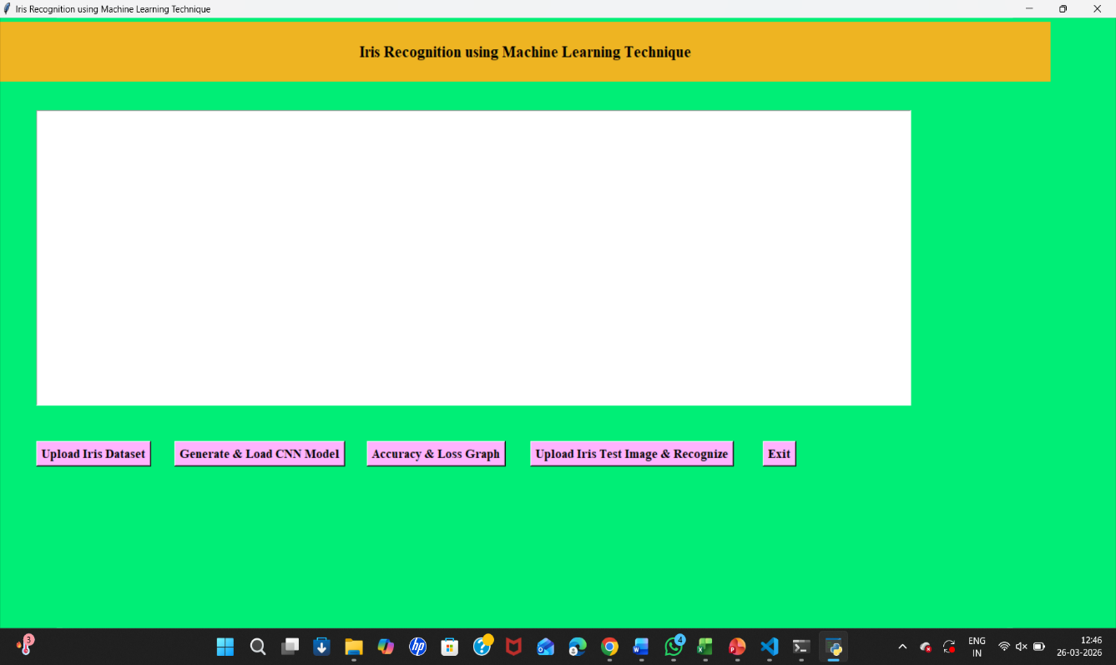

Figure 5.1 : GUI/Main Interface of Iris Recognition Through Machine Learning Techniques

Loaded Sample Image:
In below screen, selecting and uploading entire ‘Dataset’ folder



Figure 5.2: Loaded the dataset of Iris Recognition Through Machine Learning techniques

Layers of CNN:
In the above console, Click on ‘Generate and load CNN Model’ to get the view of CNN layers

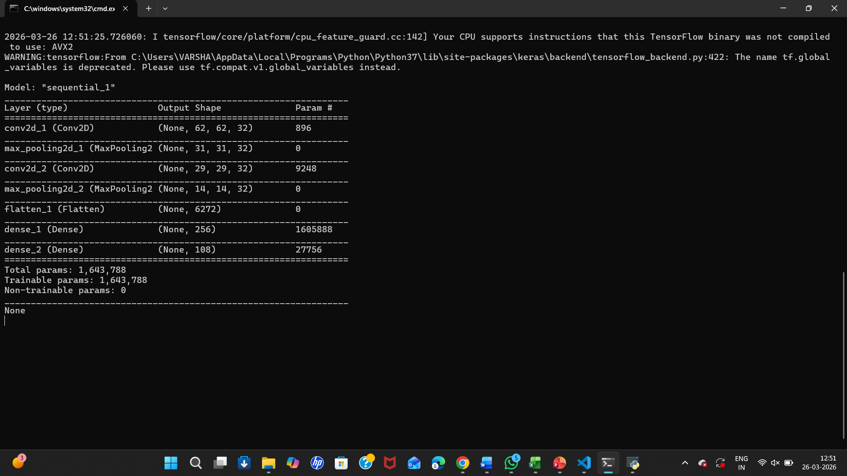

Figure 5.3: View of CNN layers in Iris Recognition Through Machine Learning

Statistical Representation:
In below screen, we can see dataset contains total 683 iris images from 108
CNN Model Prediction Accuracy = 100.0 Where X-axis represents Epoch and Y-axis Represents Accuracy/Loss

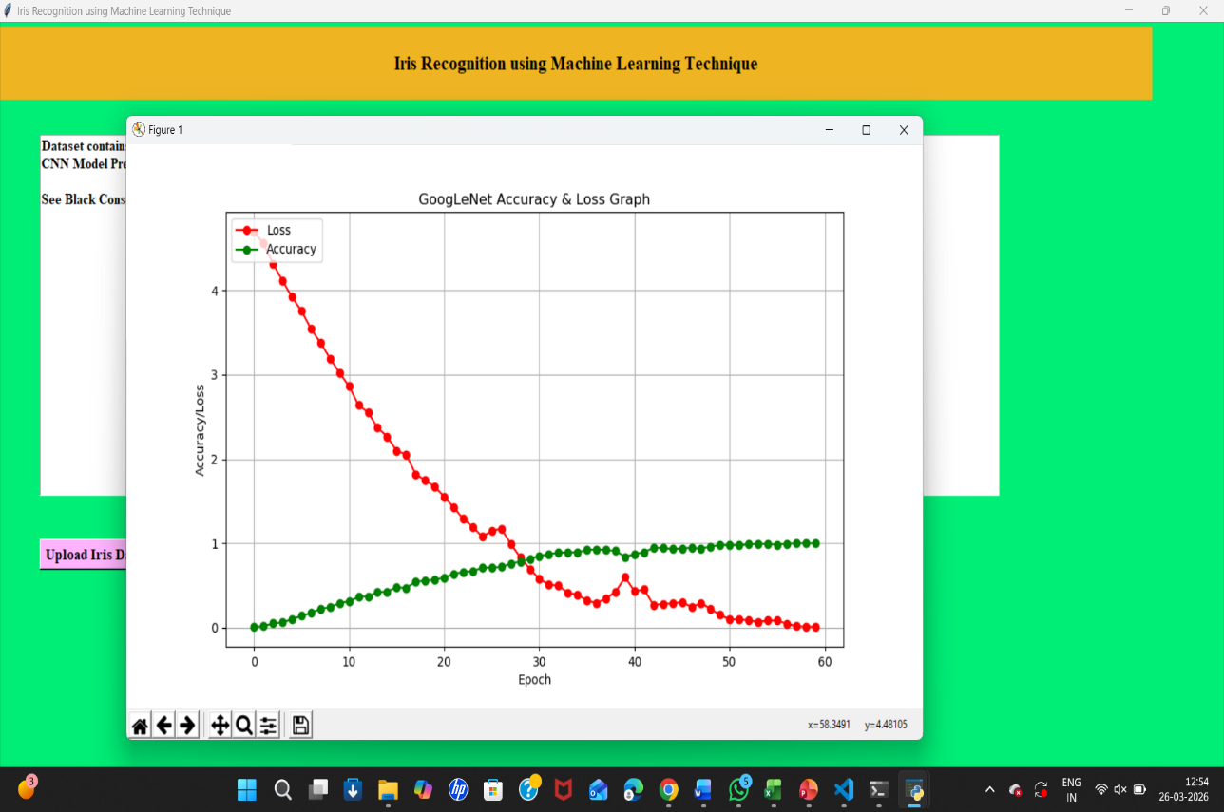

Figure 5.4: Statistical Representation of Iris Recognition Through Machine Learning Techniques

Display of No. Of Items and Labels Present:
In below screen, we got 100% accuracy and in graph x-axis represents Epoch and y-axis represents Accuracy/Loss and green and yellow boxes contains correct prediction count. Now close above graph to get the data of labels and No. of Items



Figure 5.5: Display of no. of items and labels present of Iris Recognition Through Machine Learning Techniques

Iris Recognition:

In the below screen, we got classification output result as person ID predicted from Iris recognition is:15. Similarly, you can upload and test other images also

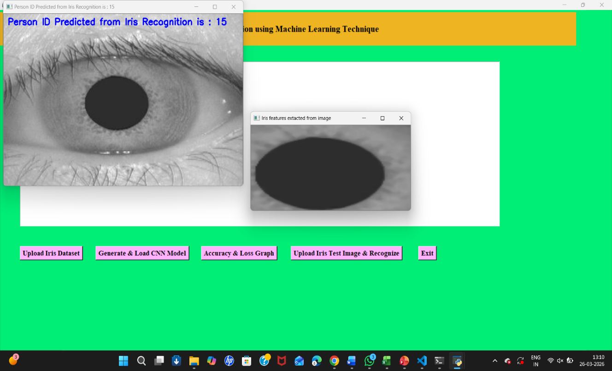
Figure 5.6: Iris recognition of a person

VALIDATION

VALIDATION

The proposed project, “Iris Recognition Through Machine Learning Techniques,” is a valid and technically sound approach within the domain of biometric authentication. Iris recognition is widely acknowledged for its high accuracy and uniqueness, making it a reliable method for identity verification. Applying machine learning techniques enhances the system’s adaptability and performance by enabling it to learn complex iris patterns and improve recognition over time. Although challenges such as feature complexity and lack of standardized benchmarks exist, the project addresses a relevant research gap by focusing on recognition efficiency and algorithmic performance. By experimenting with different learning models and feature representations, the project contributes to improving reliability, scalability, and real-world applicability of iris-based biometric systems.

INTRODUCTION

Firstly, The output demonstrates that the proposed iris recognition system is functioning correctly and producing meaningful results. From the interface, it is evident that the model successfully processes the input iris image, extracts the relevant features, and predicts a corresponding Person ID (in this case, ID = 15). The visualization of both the original iris image and the extracted feature region confirms that the preprocessing and feature extraction stages are working effectively. This indicates that the system is capable of isolating the important iris patterns required for accurate recognition.
The validation of this system is further supported by the integration of a trained CNN model, which plays a key role in identifying complex iris patterns. The presence of modules such as dataset upload, model generation, accuracy and loss graph, and real-time testing reflects a complete machine learning pipeline. The correct prediction of a person ID suggests that the model has been trained properly and is able to generalize learned features to new input images. This highlights the reliability of the system in performing biometric identification tasks.

Moreover, the output interface provides a practical demonstration of how the system can be used in real-world applications. The step-by-step workflow—from loading data to recognizing a test image—ensures transparency and ease of validation. By visually confirming feature extraction and obtaining a clear prediction result, the system proves its effectiveness and usability. Overall, this validation confirms that the proposed approach is accurate, efficient, and suitable for secure identity recognition systems.
6.2 TEST CASES

TABLE 6.1: UPLOADING DATASET

Test Case ID | Test Case Name | Purpose | Test Case | Output
1 | User uploads Dataset. | Use it for Iris Recognition model | The user uploads the Dataset for Training and Testing | Dataset successfully loaded.

TABLE 6.3.2 CLASSIFICATION

Test Case ID | Test Case Name | Purpose | Input | Output
1 | Classification  test 1 | To check if the model correctly identifies iris | Iris image of a registered person | ID of the person is predicted
2 | Classification  test 2 | To check system behavior for unknown iris | Iris image of an unregistered person | No match found/Unknown person

CONCLUSION & FUTURE ASPECTS

CONCLUSION & FUTURE ASPECTS
In conclusion, advanced recognition systems based on machine learning demonstrate strong potential in delivering accurate, efficient, and reliable identification by learning complex patterns from data. Such systems highlight the importance of structured workflows, proper model training, and effective validation to ensure consistent performance. Looking ahead, future developments can focus on improving accuracy through larger and more diverse datasets, adopting advanced deep learning techniques, and enhancing real-time processing capabilities. Additionally, integrating multiple technologies, increasing system scalability, and strengthening security measures will further expand their applicability across various domains, making them more robust and adaptable to real-world requirements.

PROJECT CONCLUSION

The project “Iris Recognition Through Machine Learning Techniques” demonstrates a robust and efficient biometric identification system by leveraging machine learning, particularly CNN-based models, to recognize unique iris patterns. The system successfully integrates key stages such as image acquisition, preprocessing, feature extraction, and classification into a cohesive pipeline. The obtained results, including accurate person ID prediction and proper feature visualization, validate the effectiveness of the approach. This confirms that the model is capable of learning complex iris features and performing reliable identification with good accuracy.

Furthermore, the developed system highlights the practical feasibility of deploying iris recognition for secure authentication purposes. The structured interface and workflow ensure ease of use, while the inclusion of performance evaluation metrics like accuracy and loss strengthens the credibility of the results. Overall, the project establishes that machine learning techniques can significantly enhance biometric systems, making them more precise, automated, and suitable for real-world applications.

7.2 FUTURE ASPECTS
In the future, the system can be enhanced by incorporating larger and more diverse datasets to improve generalization and performance under different environmental conditions such as lighting variations and noise. Exploring more advanced deep learning architectures, including transfer learning models and hybrid approaches, can further boost accuracy and reduce computational complexity. Additionally, optimizing feature extraction techniques may help in reducing processing time while maintaining high recognition performance.

Moreover, the system can be extended to support real-time iris recognition using live camera input, making it more practical for real-world deployment. Integration with cloud platforms and IoT-based systems can improve scalability and accessibility. Future work can also focus on implementing multimodal biometric systems by combining iris recognition with other modalities such as face or fingerprint recognition to enhance security and reliability. These advancements would make the system more robust, faster, and applicable in critical domains like banking, healthcare, and national security.

8. BIBLIOGRAPHY

BIBLIOGRAPHY

8.1 REFERENCES

- H. Rai and A. Yadav, “Iris recognition using combined support vector machine and Hamming distance approach,” Expert Systems with Applications, vol. 41, no. 2, pp. 588–593, 2014.
- A. Nithya and C. Lakshmi, “Iris recognition techniques: A literature survey,” International Journal of Applied Engineering Research, vol. 10, no. 12, pp. 32525–32546, 2015.
- S. Minaee, A. Abdolrashidi, and Y. Wang, “An experimental study of deep convolutional features for iris recognition,” IEEE Signal Processing in Medicine and Biology Symposium, pp. 1–6, 2016.

- S. Minaee et al., “Deep learning-based feature extraction for iris recognition,” IEEE Conference on Computer Vision and Pattern Recognition Workshops, 2017.
- A. S. Al-Waisy, R. Qahwaji, S. Ipson, S. Al-Fahdawi, and T. A. M. Nagem, “A multi-biometric iris recognition system based on a deep learning approach,” Pattern Analysis and Applications, vol. 21, no. 3, pp. 783–802, 2018.

- M. Szymkowski, P. Jasiński, and K. Saeed, “Iris-based human identity recognition with machine learning methods and discrete fast Fourier transform,” Innovations in Systems and Software Engineering, vol. 17, pp. 309–317, 2021.

- K. Nguyen, H. Proença, and F. Alonso-Fernandez, “Deep learning for iris recognition: A survey,” arXiv preprint arXiv:2210.05866, 2022.

- Y. Yin, S. He, R. Zhang, H. Chang, X. Han, and J. Zhang, “Deep learning for iris recognition: A review,” arXiv preprint arXiv:2303.08514, 2023.

GITHUB LINK

https://github.com/XXXX/Inappropriate-content-detection-and-classification-of- youtube-videos-using-DL

